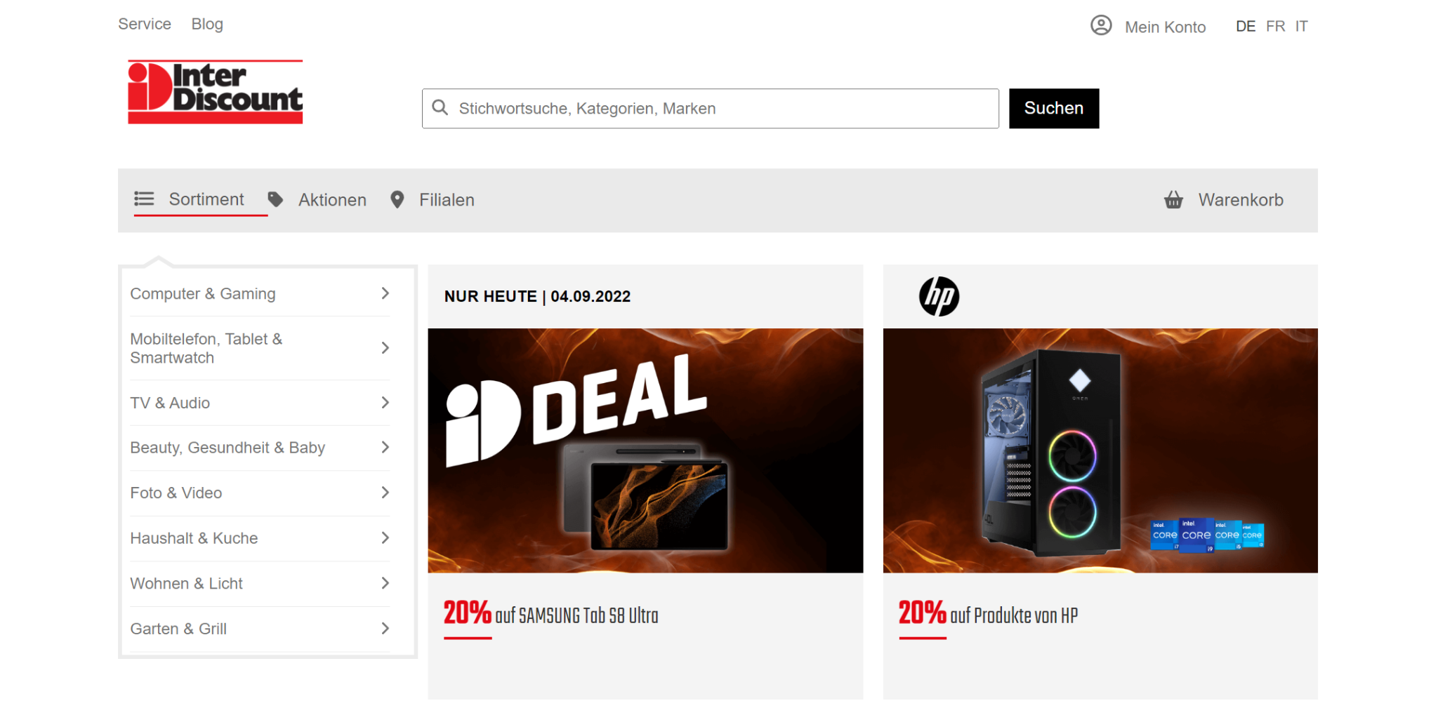
In this exercise our priority is creating main layouts and applying necessary responsive layouts and styles.
First of all you need to use flex layouts to create a responsive webpage.
There are three break points: 992px, 768px and 576px.

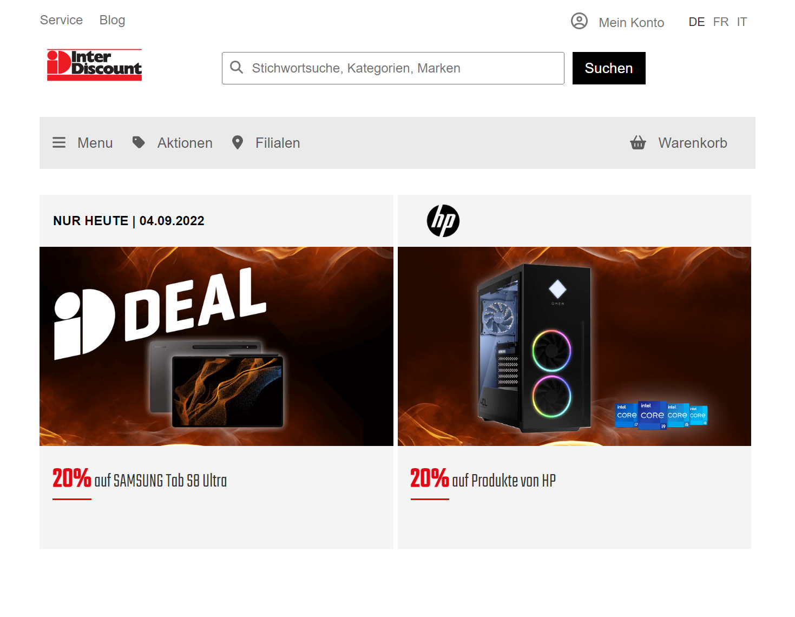 As you see in the first breakpoint (992px)
- The sidebar(item category menu) will disappear.
- Item contents will cover all width.
- Also logo of Inter Discount will get more smaller (120px*40px)
- The sortiment block will be removed.
- The Menu block will be placed instead of sortiment.

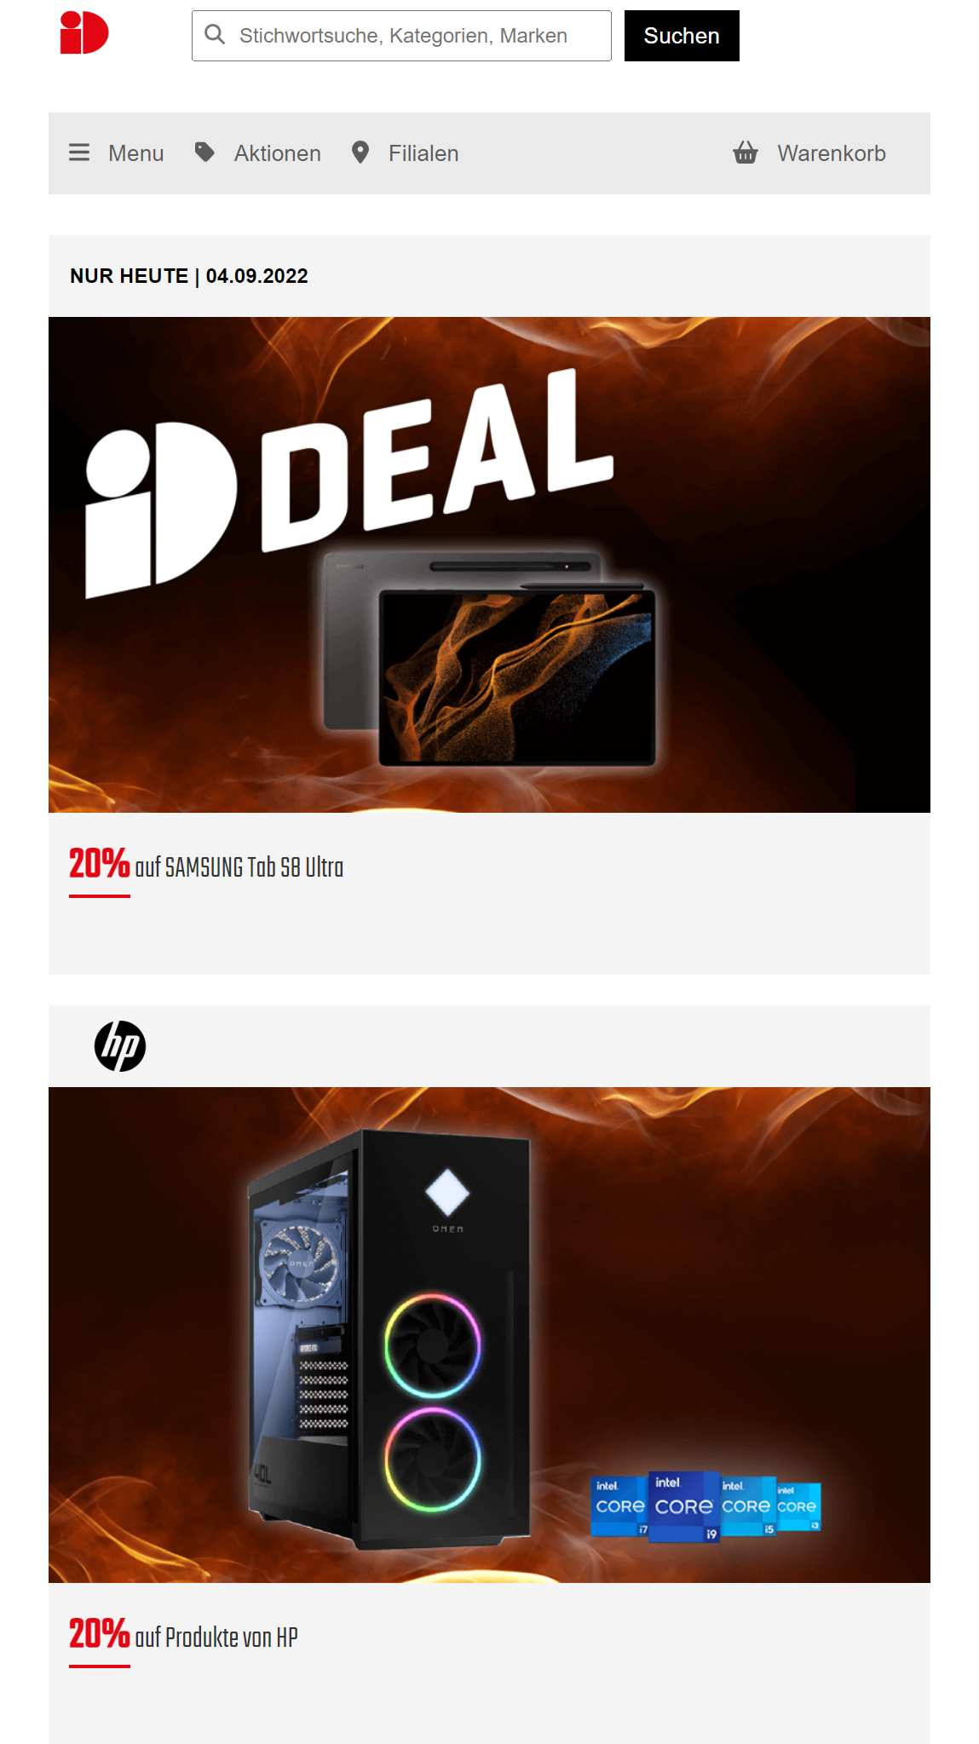
The second breakpoint will be at 778px.
- The logo of Inter Discount will be altered.
- In the content field,there would be one item in a line.
- The navigation bar which is at the top will disappear.

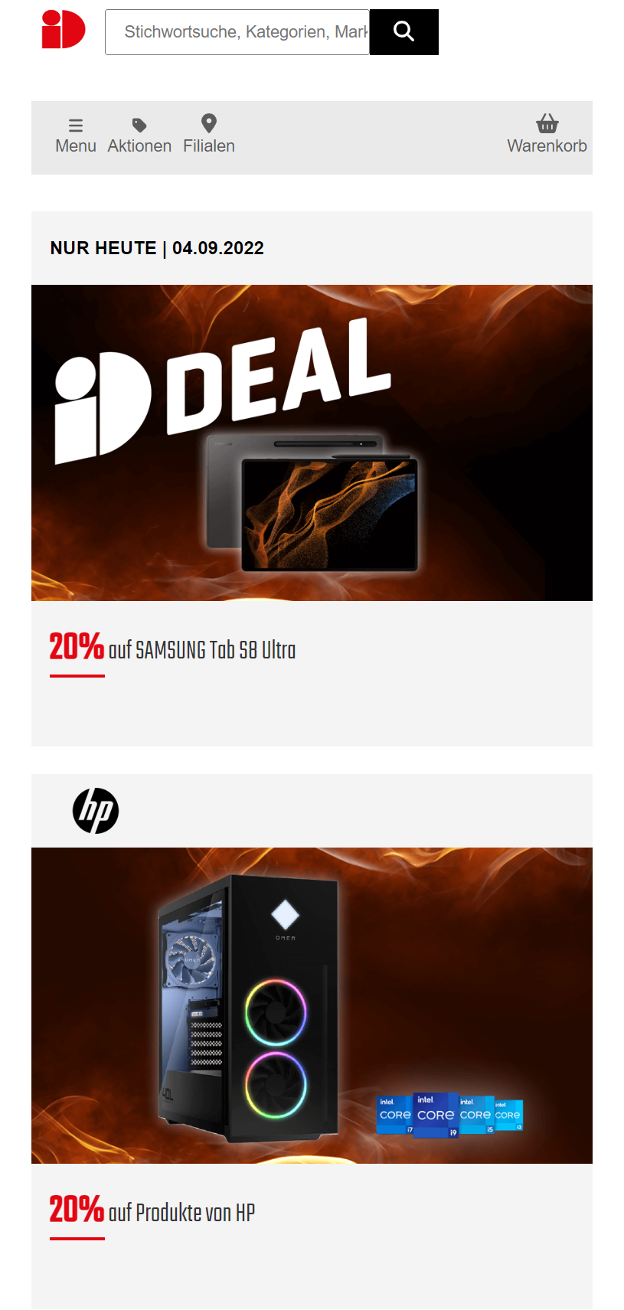
The third breakpoint will be at 576px.
- In the previous pictures you will see a magnifier icon inside the search input. At this breakpoint you need to remove this icon.
- Later, you need to change the search (suchen) button as it is seen in the picture.
- Lastly, you need to change the layouts of the menu items and icons.
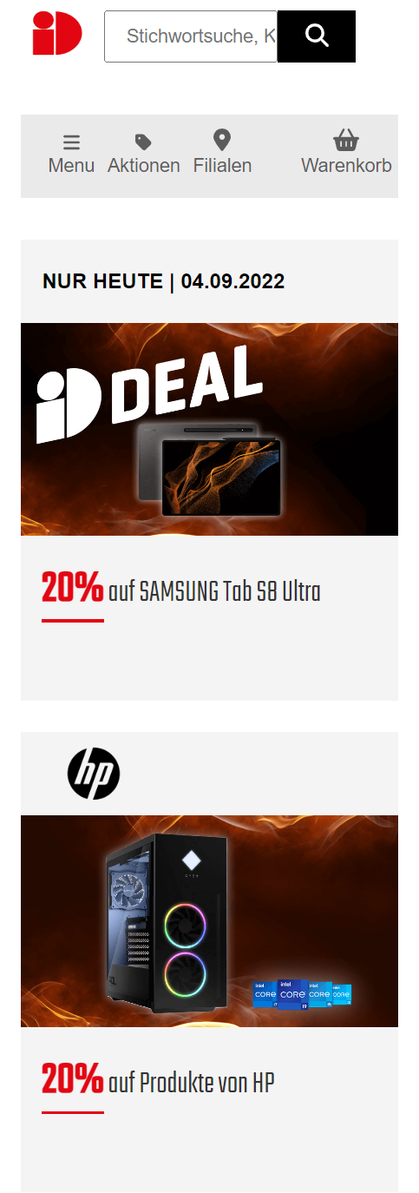
Mobile View
Your page has to be responsive. The responsiveness should last till 300px.

Good luck!

